EXHIBIT A
Joly Family Center for International Understanding :
Room Rental Rates

 | Capacity | AF member rate per hour | General public rate per hour | Non-profit rate per hour
Small classroom | 6 seated | $30.00 | $40.00 | $35.00
Large classroom | 12 seated | $40.00 | $50.00 | $45.00
Children’s classroom | 8 seated | $40.00 | $50.00 | $45.00
Vaaler Galerie | 40 seated,  65 standing | $60.00 | $85.00 | $70.00
Bacig Lounge | 20 standing | $40.00 | $50.00 | $45.00
Teaching Kitchen | 12 seated,  20 standing | $60.00 | $85.00 | $70.00
Talle Lobby | 60 standing | $60.00 | $75.00 | $65.00
La Grande Salle | 100 auditorium, 60 banquet | $110.00 | $160.00 | $130.00

Rental of Classrooms includes use of tables, chairs, whiteboard/Smart-Board and Wi-Fi access. Rental of La Grande Salle and La Galerie includes use of tables, chairs, AV system, projector, screen and Wi-Fi access. Rental of the Teaching Kitchen includes use of tables, chairs, stovetop, oven, dishwasher, plate ware and silverware.

Tables available:
- Ten 60-inch round tables
- Five 30-inch-high top tables
- Ten rectangular banquet tables
- Table linens are not provided by AFMSP.
Certificate of Insurance listing AFMSP Real Estate Holdings LLC as additional insured may be required. Payment of 50% of rental fee is required to confirm a room rental. An additional cleaning fee may be assessed if the space is not left in order, at discretion of Licensor.

Events that take place outside of regular AFMSP hours of operation require an AFMSP staff member to be on-site during the entirety of the event, including tear-down. The hourly rate for an AFMSP staff member at your event is $25 per hour. Services of AFMSP staff, such as hosting, serving, cleaning or otherwise working at the event, are not included in rental.

Please contact us at rentals@afmsp.org or 612 332 0436 with any questions or to inquire about availability.
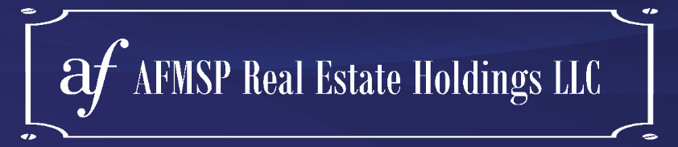

EXHIBIT B
EXHIBIT B
Joly Family Center for International Understanding :
Catering & Bar Options

According to the City of Minneapolis: “Most events are public events, including ticketed events. If general members of the public can purchase tickets or attend for free, the event is public. Private events are those that only a pre-defined group of people are invited to or can attend. Examples include family reunions, club or team celebrations and employee appreciation dinners.

If you are organizing a public event where food or beverages will be sold or given away in the City of Minneapolis, you will need an Event Food Sponsor Permit. This includes sampling (marketing) of food and/or beverage products. Selling or giving away food or beverages without a permit will result in closure and a fine. Private events do not require food permits.

If you need help determining if your event is public or private contact 311 and ask for a Health Inspector with the events permit team.”

If alcohol is to be served at a public event, a Liquor License delivered by the city of Minneapolis must be presented to AFMSP at least 10 days before the date of rental. A Temporary Alcohol Permit is required by the city of Minneapolis unless you hire a catering service that has a liquor license.

Catering services
- Chow Girls
  - Has a liquor license
  - https://www.chowgirls.net/
- D’Amico
  - Has a liquor license
  - https://damicocatering.com/
- Breaking Bread
  - Has a liquor license
  - https://breakingbreadfoods.com/catering/
- Valerie’s French Kitchen
  - Does not have a liquor license
  - Site web : valeriesfrenchkitchen.com
- Oh Crêpe!
  - Does not have a liquor license
  - https://www.ohcrepemn.com/
Bartending services
- Hire a Host
- With a Twist
- Liquid Motion
If you have any questions, please ask us at 612 332 0436 or rentals@afmsp.org

